# Modeling Burn Wound Healing

## Difference with normal Wound Healing

* Hemostasis:
* Inflammation:
* Proliferation:
* Remodeling:

What differences in this pathway?

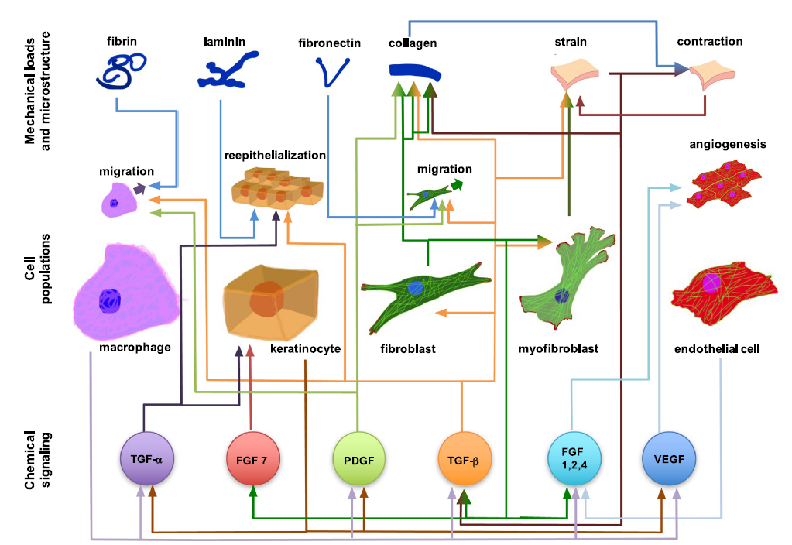

### Model Spatio-temporal Wound Domain (Geometrical Considerations):

In order to examine the role that the wound shape or surface extent plays in the healing process, a 3d model will be constructed.

3 zones:

* Coagulation
* Stasis
* Hyperaemia

An external file that holds a picture, illustration, etc.
Object name is fig-3.jpg

### Modeling Framework:

discrete vs. continuum

### Species to be included:

oxygen, inflammatory cells, VEGF, TGF-β, fibroblasts, ECM,

### Development of Model Equations:

### Estimation of Model Parameter Values: